Dear Chamber Member,

The 2022 Chamber theme is “Catch the Passion.” I chose this theme due to the passion many area business owners and residents display when interacting with others from not only our community but far reaching. We all have a passion for Alexandria – it’s why we love to have people come here to work, shop, visit, and live.
Being a native Alexandrian, I have taken this passion for our community for granted. When I completed college and was offered a job in Alexandria, I didn’t hesitate to move back “home” to begin my professional career. That was when I first began to notice the passion our residents have for our community. It was brought to my attention again at a men’s group gathering, at which members shared why they chose to live in Alexandria. Much of this conversation led to how passionate our residents and business owners are.
The Alexandria area is blessed to have a diverse array of businesses, which not only support one another but are also generous in giving back to the community. Many of these acts go unpublicized, but none go unnoticed. Our local education system is outstanding. This draws communities far and wide to come see just how we do it. The non-profit sector here is thriving. Without passion for what we do, this does not happen.
The passion we all bring to our businesses, family, friends, and non-profits is what keeps our community growing and thriving, even through some difficult times over the past few years. We have and will continue to band together in times of need and prosperity. This passion is contagious. It keeps the lights shining brightly on what we have here and continues to attract new people that want a piece of what we have to offer.
I urge each of you to share your passion with others and be the “electricity” that powers the bright lights that shine on our outstanding community.
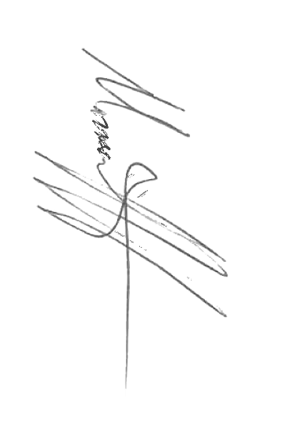
I would like to personally thank every one of you for your membership and commitment to the Alexandria Lakes Area Chamber of Commerce. While we continue to face challenges, it is important that we all continue to move forward. The Chamber is there to help your business grow and prosper by living out its mission of promoting the area as “the ultimate destination to live, work, play, and prosper.”

